learning enterprises ROMANIA/CROATIA

## ADDENDUM FOR PROGRAM YEAR 2016

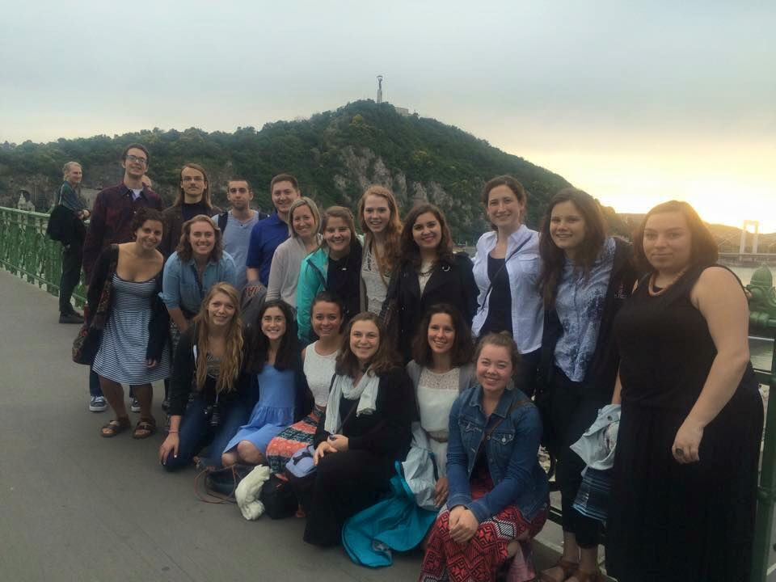

# Table of Contents

1. **Program Information** 
   1. Staff
   2. Program History
   3. Program Schedule
      1. LE Application Dates
      2. Romania/Croatia Program Dates
2. **Locations** 
   1. Romania and Croatian Villages
   2. Sunny Village Came
   3. Koprivnica Youth Center
   4. Romanian Orphanages

1. **Teaching**
   1. General Tips/Insight
   2. Teaching Materials
2. **Country Information** 
   1. Background Statistics
      1. Romania
      2. Croatia
   2. Culturally Sensitive Issues
   3. Language
      1. Hungarian and Romanian
      2. Croatian
   4. Currency
   5. Excursions/Points of Interest
3. **Preparing for you trip!** 
   1. Finding a Flight
   2. Passports and Visas
   3. Health and Safety
   4. Insurance
   5. Communication
   6. What to Pack
   7. Money and Banking

### Disclaimer for the addendum

Your host village in this program country is somewhere that can benefit from a volunteer English teacher. You should expect to be the only LE volunteer in your village (though in some cases, we send two volunteers to one location). This means that you may not have direct access to an American. It may not be a very well‐developed community, and the ease of transportation infrastructures is not the same as you could expect in a high‐functioning urban areas. Transportation varies country‐to‐country and village‐to village (consult the remaining portions of this addendum for info more specific to your host region), and most are connected by public bus routes. The frequency of the bus/train schedule will not be the same as in urban areas, and you should not rely on schedules or purchasing tickets via the internet. You will need to consult with your host family and PD when arranging transportation. In many but not all cases, host families own cars or share vehicles with neighbors/relatives. All villages have phones and internet connections, and many but not all host families have internet in their homes. For families who have Internet connectivity, it may not be the same level/consistency as in developed, urban area. Volunteers who are very concerned with being in touch all the time should invest in their own cell phones and you can talk to your PD about it. Villages will have access to a medical clinic or hospital in the nearest larger city. Be prepared to live in a place with different social norms that may challenge and fascinate you. As a volunteer you need to be culturally sensitive and your host family may not have the same views as you. You should reach out to your Program Director or Director of Programming if you ever feel uncomfortable.

# PROGRAM INFORMATION

### STAFF

**PROGRAM DIRECTOR**

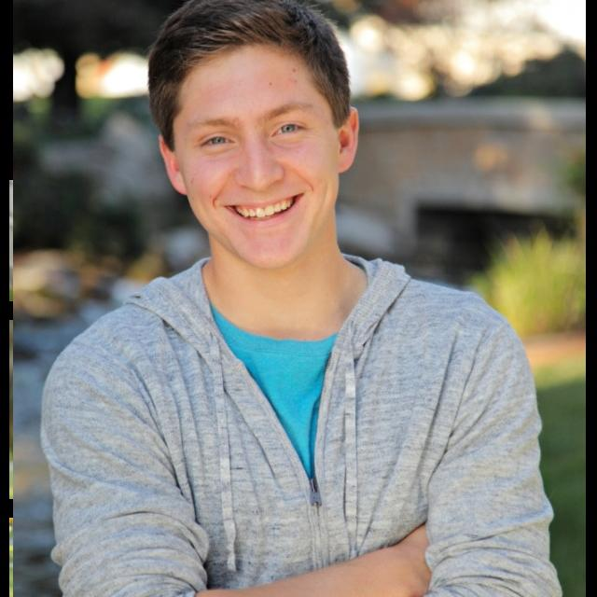*Alex Sanders*

Hello! I am the Program Director for the Program Year of 2016. I am extremely grateful to have the opportunity to lead an LE Romania/Croatia volunteer trip. I cannot wait to return to Eastern Europe and further the LE mission to create cross-cultural exchange and spread the spirit of volunteerism. As PD, I have many responsibilities both during and before the summer begins, but I know this experience will be beyond rewarding. I am excited to find an outstanding team of change makers, and have another successful summer in Romania and Croatia!

**What do I do as Program Director?**

* I keep in constant communication with the 3 country coordinators to ensure a great program.
* Interview and accept volunteers for the program.
* Provide guidance and support through emails and skype meetings for volunteers as they prepare for their trip.
* Act as a point of contact for any questions or concerns that a volunteer has before, during, or after the trip.
* Organize and lead the Orientation, Midpoint Break, and Closing Session.

**What Do I Expect from Volunteers?**

* I hope to create a team of **open-minded and loving** individuals.
* Individuals with a sense of **adventure** and of course a **great sense of humor.**
* Volunteers that are **tough and resilient**. This program requires **independence** and **perseverance.**
* Volunteers that **genuinely want to make a difference**.

If there are any questions or concerns please don’t hesitate to email me at [romania.croatia@learningenterprises.org](mailto:romania.croatia@learningenterprises.org)

LE Love,

Alex Sanders

**COUNTRY COORDINATORS**

**Romania Country Coordinator: Kinga Popa**

**Croatia Co-Country Coordinators: Helena Hecimovic & Drina Bešenic**

*Kinga Popa*

Kinga was born in Oradea, Romania. In 2007, she graduated from the Partium Christian University with a degree in social work. She now lives in Budapest, Hungary, where she works in a dubbing studio. In 2004, Kinga started to volunteer for International Children’s Safety Service in Oradea, which is where she first heard about Learning Enterprises. The next year, she became Country Coordinator in Romania. This is her TWELFTH year as Country Coordinator!! Each year she goes above and beyond to ensure that every aspect of the program is a success. When she took the position 12 years ago, she knew that the job would be a challenge, but she didn’t realize it would be such an amazing experience.

*Helena Hecimovic*

In 2003, Helena helped establish the Croatia Learning Enterprises program. She is now responsible for the Sunny Village Camp and Koprivnica locations in Croatia. Helena teaches English in Croatia: she is the founder of HELLO English Language Club, and she runs the Sunny Village English Summer Camp in Jagnjedovec, near Koprivnica (which receives 3 LE volunteers each summer). Helena also serves on the Koprivnica city council, is president of the Croatian Fraternal Union of America for her area of Croatia, and president of the Drava League, an association of eight environmental NGOs dedicated to conservation and sustainable development programs in and around the Drava River. Helena’s husband, Davor, is the local surgeon as well as a master craftsman who constructed and furnished all of the buildings in the Sunny Village Camp. They are parents to two children, Danko and Lana, who are also active in the family’s many pursuits.

*Drina Besenic*

Drina and Helena will work together to ensure that the Croatia program is another success. Drina will be in charge of Biograd na Moru and the 1 or 2 additional Croatian villages that she adds for this year (so exciting!!). She lives in the stunning coastal town of Biograd, where she works at the city hall. She has a 15 year old daughter, Nina. They love to go to the beach and swim in the Adriatic Sea. Drina is a fiercely independent and strong woman, and she will be an awesome addition to the LE Romania/Croatia program. Drina originally contacted Helena a few years ago after she read about the Croatian LE program in the newspaper, and ever since then Drina has hosted 4 volunteers every summer. She works hard to make sure that the LE classes are a success and that our volunteers are happy.

### PROGRAM HISTORY

**HISTORY OF LEARNING ENTERPRISES**

The history of LE as a whole can be found at this link: <http://www.learningenterprises.org/news-events/history>

**HISTORY OF THE ROMANIA/CROATIA PROGRAM**

**LE Romania** began in 1993, one year after LE’s founder, Adam Tolnay, started the initial program in Hungary. During its very first year, LE Romania consisted of about ten volunteers in western Romania. Today, it is a strong program with a solid foundation that has lasted many years!

LE Romania became **LE Romania/Croatia** in 2003 with Helena Hecimovic’s Sunny Village Camp, a unique part of the program that still hosts volunteers today. Croatia is currently expanding beyond Sunny Village camp, Koprivnica, and Biograd villages. It is an exciting time for the Romania/Croatia program because it is extremely accomplished yet still possesses unlimited potential.

### PROGRAM DATES

**LE APPLICATION DATES**

**•** **Sunday November 22:** Applications open  
• **Sunday January 10:**Priority Application deadline at 23:59 PST.  
• **Sunday February 14:** All applications close at 23:59 PST.  
• Decisions and offers are made on a rolling basis, no later than **Sunday March 9th**

**PROGRAM DATES**

**Dates for the Program Dates are tentative**

1. Romania/Croatia PY16 Timeline:
   * **Orientation: June 21st-June 25th**
   * Travel to First Session: June 26th
   * First Session Teaching Begins: June 27th
   * **First Session: June 27th- July 14th**
   * Travel to Midpoint Break: July 15th (Croatia July 14th)
   * **Midpoint Break: July15th-July 17th**
   * Travel to Second Session: July 18th
   * First Day of Teaching: July 19th
   * **Second Session: July 19th- August 5th**
   * Travel to Closing Session: August 6th
   * **Closing Session (Optional): August 7th-August 9th**

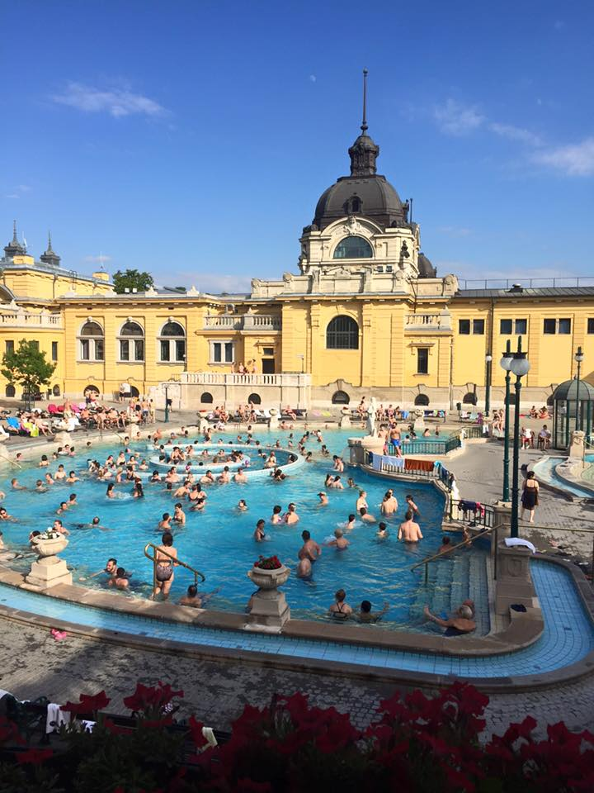**ORIENTATION**

Orientation will take place in the absolutely amazing city of Budapest, Hungary. Budapest is filled with many exciting things to do, and volunteers will realize that 4 days is just not enough time there! Each day I will lead educational sessions about the Romania/Croatia program. These ed sessions are meant to familiarize the volunteers with the program and give volunteers the knowledge they will need to go out to their host communities. We will practice lesson planning and problem solving, discuss the cultural backgrounds of the regions, delve into the languages that we will hear, discuss the implications of the work we will be doing in our communities, conduct 1-on-1 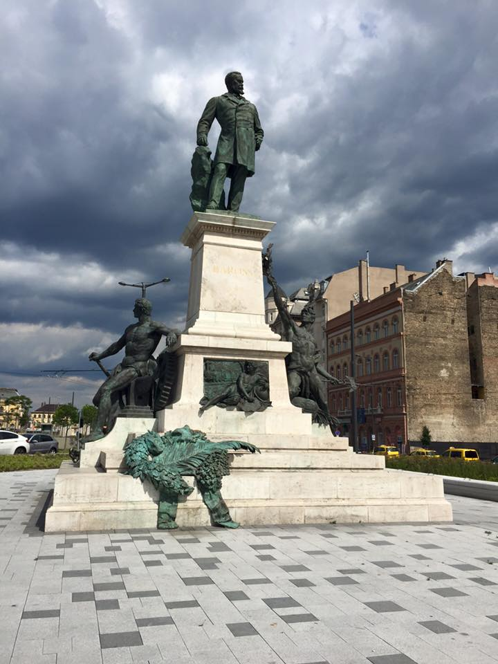chats, and answer any questions that volunteers have. While this orientation is meant to be educational for the volunteers, there will be ample time to explore the city of Budapest! Volunteers can take day tours through the city, hang out in the parks, visit the Hungarian Parliament building, or visit some of the many museums! As a group the LE team will take a nighttime boat tour of the Danube river, and take a swim in the most famous thermal bath in Budapest, Szechenui Baths!

Orientation will be a memorable experience, as Budapest easily became my favorite city in the world. I hope that it will be yours too! This will be a time of bonding. By the end of orientation many volunteers have created life-long friendships.

**MIDPOINT BREAK**

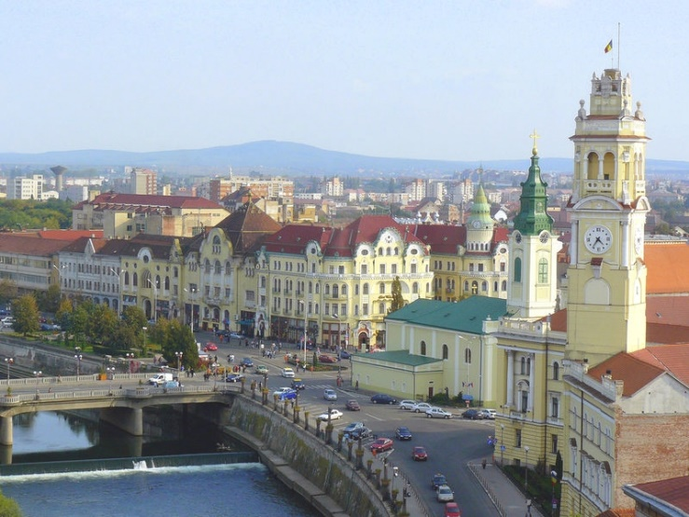 After the first session is over volunteers will travel to Oradea, Romania where we will all reunite for 2 days! Oradea is the 10th largest city in Romania with a population just under 200,000. It has a beautiful town center, a large shopping mall, and an exciting night life.

This will be a great opportunity to share stories, both successes and failures, and swap lesson plans or ideas. You will love the opportunity to speak with other native English speakers again! I will hold debriefing sessions and one-on-ones with each volunteer. This weekend will be much needed before you head off to your second session of teaching.

**CLOSING SESSION**

Closing session will most likely take place in Budapest. This will be a time of reflecting and relaxing. I am a strong believer that in order for volunteers to get the most out of their work they there needs to be discussions before, during, and after the work is done. However, I am making closing session **optional** because of how expensive this trip already is. I do not want to force any volunteers to stay abroad any longer than they need to.

Reflection is an extremely important part of the LE experience, and I look forward to a great group discussion when we all reunite for the last time. Many volunteers find it beneficial to put their experiences into words, and share stories with others who have experienced something similar. At this point in the summer our group will have grown extremely close, and it will be sad for us to all part ways.

# II. LOCATIONS

** The LE Romania/Croatia program offers a diverse range of locations. There are **FOUR** different placement options spread across two countries. Each volunteer will placed in two different locations, and they will switch after midpoint break. It is likely that you could spend one session in Romania and one session in Croatia, or both sessions in Romania since there are more locations in Romania (i.e. you spend the first three weeks at Sunny Day Camp and the second three weeks in a Romanian village, or you could spend the first three weeks in a Croatian host village and the second three weeks in a Romanian orphanage). It is important to note that Sunny Day Camp and the Romanian Orphanage Foundation have limited spots, so some volunteers may spend all of their time with a host family in a village. Volunteer preferences will be taken into account when placing volunteers.

### Option 1: Village Stays (Croatia and Romania):

Your experience living with a host family will be one the most defining and gratifying experiences you will have during the Romania/Croatia program. Some host families will overflow with children; others will be empty nesters. Some will have an array of modern amenities in their homes; others might not even have indoor plumbing. What the families share, though, is that certain Eastern European warmth. My host mother and sister in Romania actually shared a tiny futon bed so I could have my own room for the entire three weeks. I was pretty much stunned by their generosity. It is the absolute best way to truly experience authentic Eastern Europe culture on a deeper level than any average tourist. Many host families will go out of their way to show volunteers the local sites. You will generally be the guest of honor at every local birthday party, wedding or festival. Most households will have limited amenities, but all will abound in liveliness and, of course, food. They are not paid to participate in the program and graciously open their homes and their hearts to Learning Enterprises volunteers. You will find it difficult to say goodbye after three weeks.

As host families are not paid to host volunteers and simply do so in order to benefit their community. Therefore, it is expected that Learning Enterprises volunteers show their host families the utmost respect. In every situation volunteers must be kind, gracious and considerate. If your host family asks you to be home at a certain time at night or tells you to not go to a certain part of town, respect their wishes. Your host family will want to show you their culture, whether that means taking you to a local waterfall or teaching you how to make homemade jam (my Romanian host mother’s apricot jam was unreal). Make sure you show your appreciation for their hospitality. Spending time with your host family is the absolute best way to get to know Eastern Europe. I will never forget the night my host brothers took me to a Croatian night club and I participated in a traditional group folkdance. Or the time my host family in Romania took me to see a national park where lotus flowers grow. It is also really important to keep your host family informed of your plans. Let them know several days in advance if you are meeting a friend for a daytrip, they may have something already planned for you.

Many host families will have lower living standards than is common in the Western world. Most, if not all families, will have running water and electricity, but you may be placed in a village where you will only be able to shower 2 or 3 times a week. You will probably have access to a phone, but you may not have access to the internet. Internet, if your host family does have it, may be extremely spotty. If your family lives in the country side, they will probably have a car of some sort.

**You might run into awkward host family situations or miscommunications. Catherine provided a prime example of this type of situation: “I was sort of shocked when my host brothers in Croatia butchered one of their sheep one morning and a huge bowl of sheep intestines showed up on the breakfast table. My families will raise chickens, sheep, pigs or other livestock in their backyards.”**

Your host family may or may not have an English speaker in it. Either way, you will enjoy the beauty in discovering universal languages such as sports, music, and laughter. Also, when I encountered language barriers, I would sometimes communicate by making silly hand gestures, speaking very broken English, using the extremely inaccurate Google Translate, drawing pictures, or just straight up smiling and pointing. In other cases, one of your host family members could be totally fluent in English.

Most likely your host family will serve you absolutely delicious food. Eastern European cooking tends to be hardy. Hungarian specialties include cabbage stuffed with rice and ground beef, cold cherry soup, and hearty meat stews, and lots of bread. Croatian cooking often includes a heavy handed use of paprika, lots of lamb, zucchini pancakes, and delicious seafood if you’re on the coast!

Many host families will have a garden in their backyards and the produce is unbelievable fresh. You may have no idea what you are eating at times. Meat factors heavily into a lot of Eastern European cooking. As a guest in their home, volunteers must try to keep an open mind. Learning Enterprises would not be possibly without are fantastic host families!

**Sample Weekday in a Village**

8:00 Wake up; Breakfast

9:00 First class

10:00 Second class

11:00 Break; Lunch

1:00 Third class

2:00 Hang out with students; play with host family

7:00 Dinner

8:00 Plan classes for following day

### Option 2: Sunny Village Camp, Croatia

Set in beautiful rural Croatia, Sunny Village is a little haven of fun and learning. As a counselor, you will help in running typical camp activities that focus on the development of kids’ English language skills. You might help lead a nature walk, deliver swim lessons, offer a game of dictionary, and in each activity, work with campers on developing their English skills. While you will be afforded free time during the day, volunteers at the camp work long hours, staying with the campers from morning until they go to bed at night. Once the campers are asleep, volunteers can hang out with the other camp counselors, who hail from all over the world. The counselors often stay up later than is wise talking politics and comparing cultures. You will work alongside Helena Hecimovic, the camp director, as well as other counselors your age from Croatia. Helena’s family is incredibly warm and they are very devoted to their camp. The camp has comfortable lodging and showers, and all meals are provided. The camp site is absolutely gorgeous, and the setting is pretty idyllic. Volunteers always enjoy getting to know the other councilors at the camp as well as it provides a great opportunity to connect with Croatians their own age. Past camp volunteers have enjoyed working with the enthusiastic children, many of whom have very advanced English skills. About four volunteers will go to the camp as councilors for the first session. Volunteers who teach at the Youth Center will also live in the camp.

*Statement from Leila, a volunteer who stayed at the camp in 2015:*

*“The camp is really hard work, but 100% worth it. As a camp counselor, you are on-duty from 8am to 10pm -- and you have to be attentive and professional nearly the entire time. The camp is an incredible place and absolutely the best three weeks of my life, but be prepared to eat, sleep, and breathe counselorship. There are 20-30 children and they are everywhere (and want constant attention). The camp is pretty far from civilization except a small general/convenience store (where they will judge you heavily), but the host family is very accomodating about everything you need. Regardless, be sure to arrive with everything you need to survive for 3 weeks, because it may be hard to get it otherwise. “*

**Sample Day at Camp**

8:00 Wake up; Breakfast with campers

9:00 Activities with campers

12:00 Lunch

1:00 Break (without campers)

4:00 Activities with camper’s resume

7:00 Dinner

### Option 3: Koprivnica Youth Center (Croatia**):**

The newly built Koprivnica Youth Center is located in the center of Koprivnica, a lively Croatian city of 25,000. As a volunteer there, you will organize English language classes, arts and crafts classes, and field trips to other parts of Croatia. Volunteers will teach several English classes daily. When you’re not teaching at the Youth Center, you will spend your time at the Sunny Village Camp. Volunteers will sleep and dine at the day camp. Volunteers who work at the Youth Camp will have to bike back and forth to the town center every day. While the Youth Center option is similar in many respects to the Sunny Village Camp option, it affords volunteers the chance to break up the structure of their day.

**Sample day at Youth Center**

9:00 Bike or drive to Koprivnica

10:00 First English class

11:00 Second English class

12:00 Return to camp

1:00 Break (without campers)

4:00 Activities with campers

7:00 Dinner

8:00 Low‐key activities (Scrabble, Pictionary)

10:00 Campers asleep; Free time

### Option 4: Romanian Orphanage

**Background of Romanian orphanages with LE**: Three years ago, LE successfully pioneered a unique aspect of the Romania/Croatia Program in partnership with the Romania Orphanage Foundation. The foundation has many orphanages in Romania and cares for about 1,800 children total. Approximately 4 volunteers will live and teach in a Romania orphanage each session. The volunteers live together in the orphanage itself, which allows them to connect with each other and their students on an incredibly meaningful level.

A PD’s experience:

“*My experience at Salonta orphanage was defined by universal languages and an appreciation for simplicity. Although I often felt frustrated by the steep language barrier, I went to bed every night feeling content because of the small yet impactful moments that filled each day. My favorite moments at the orphanage were when the children and I discovered common languages, such as sports. I’ll never forget how shocked some of the boys were when they learned that I, (a girl!), could juggle and pass a soccer ball. Soon enough, we played soccer almost every day on their worn-down, patchy field with two crooked goal posts on either end. Even though we didn’t speak each other’s languages, we made it work simply because we understood the same sport. The passes, dribbles, sprints, high-fives, and shouts of names were the only forms of communication that we needed. Our games would always become too competitive, which made them even more fun! Another universal language we discovered was music. I was so excited when I realized that most of the children knew “The Cup Song” from Pitch Perfect. They tapped out the beat on cups while I sang. One of my favorite boys, Atilla, even tried to learn all the lyrics; he just mumbled out similar-sounding syllables as I sang the real words since it was pretty advanced vocabulary for his level. It was a great effort, though! I was proud. ☺ Some of my other favorite universal languages were drawing, dancing, smiling, and laughing. It sounds cheesy, but I felt most connected to the children when we laughed and acted goofy together. Although Eva and I only taught English for one or two hours every morning, the love that was exchanged between us and the children was why I went to bed every night feeling like we made an impact—no matter how small or fleeting it was. Along with my excitement for universal languages, I also embraced the beauty of simplicity. Life at the orphanage was minimal. Every day we ate plain white bread, cucumbers, and hot tea for breakfast. Eva and I taught our lessons on a picnic bench or on the pavement using mainly construction paper, markers, chalk, and a dirty tennis ball. During the evenings we sat on our front steps and watched the sun set as the boys milked the brown goat named Susie. Some of the boys chased the other animals around the pen—the object of their game was to try and catch a goat or sheep before it got away. They spoke and shouted in Hungarian; I only understood their laughter as they poked fun at each other and dashed after the sheep. It was a quintessential orphanage moment because it summed up their basic ways of living that were innate, pure, and full of happiness. I could see the contentment on their faces as they ran around the pen and hung with Susie. The children’s love and support for one another were clear. They always had a smile to give and their smiles were always more than enough to receive. It was during those times when I acknowledged the brilliance of simplicity and when I felt deeply grateful for everything that I learned at the orphanage.”* ~ Haley Moen PD 2015

**Please note: The main responsibility a volunteer has at the orphanage is to just spend time with the children—play soccer, weave bracelets, sing top 40 songs, and enforce the importance of education in general. You will not have structured 6 hours’ worth of lessons every day like the other volunteers in traditional village settings. Rather, you will teach English organically as the day goes on. Your primary efforts will be put into integrating yourself into the orphanage’s community, which can be difficult at times. I will hold special training sessions about the orphanage locations during orientation.**

Volunteers who teach in the orphanage need to be prepared for the realities of the Romanian Social Services. I suggest doing some research on the history of Romanian orphanages prior to the trip if you are placed in an orphanage. The children at the orphanages do not have stable family relationships; some have been emotionally, physically, and sexually abused, and many are coping with trauma. The children at the orphanage are the most disadvantaged children Learning Enterprises works with, and the impact volunteers can make is tremendous.

The orphanage is run solely on donations, so children are brought to whatever orphanage currently has the most resources. Therefore, volunteers may have the opportunity to work with some children for only a short period of time. Because volunteers are living in the orphanage, they will eat all of their meals there. Food was simply—mostly just bread, cucumbers, and cheese.

# III TEACHING

**Teaching is the most important aspect of the Learning Enterprises program.**

1. General Tips/Insight
   * All volunteers are required to teach 3-6 hours a day
   * Let your own personality and creativity guide your classroom!
     + You get to decide what to teach and how to teach it
   * I will do some basic teaching training with volunteers during Orientation
     + Lesson Planning
     + Idea sharing
     + Troublesome kids
     + The rest is up to you!
2. Teaching Material
   * Materials provided for you vary depending on the location you are placed. I will go into detail about this in a future email to the volunteers who are hired for this year’s program.
   * Paper is really the only material you can count on having. It is possible that your villages will have other supplies, but you should not count on it. You might consider bringing:
     + Notebook for lesson planning
     + Tape, markers/crayons/color pencils
     + Map of the world or just of US/UK
     + Candy for small prizes
     + Small items that can be used during teaching that won’t take up too much space
     + Magazines from the US/UK
     + Photos from home

# IV COUNTRY INFORMATIOn

### Background Information:

1. Romania
   1. The principalities of Wallachia and Moldavia - for centuries under the suzerainty of the Turkish Ottoman Empire - secured their autonomy in 1856; they were de facto linked in 1859 and formally united in 1862 under the new name of Romania. The country gained recognition of its independence in 1878. It joined the Allied Powers in World War I and acquired new territories - most notably Transylvania - following the conflict. In 1940, Romania allied with the Axis powers and participated in the 1941 German invasion of the USSR. Three years later, overrun by the Soviets, Romania signed an armistice. The post-war Soviet occupation led to the formation of a communist "people's republic" in 1947 and the abdication of the king. The decades-long rule of dictator Nicolae CEAUSESCU, who took power in 1965, and his Securitate police state became increasingly oppressive and draconian through the 1980s. CEAUSESCU was overthrown and executed in late 1989. Former communists dominated the government until 1996 when they were swept from power. Romania joined NATO in 2004 and the EU in 2007.
2. Croatia
   1. The lands that today comprise Croatia were part of the Austro-Hungarian Empire until the close of World War I. In 1918, the Croats, Serbs, and Slovenes formed a kingdom known after 1929 as Yugoslavia. Following World War II, Yugoslavia became a federal independent communist state under the strong hand of Marshal TITO. Although Croatia declared its independence from Yugoslavia in 1991, it took four years of sporadic, but often bitter, fighting before occupying Serb armies were mostly cleared from Croatian lands, along with a majority of Croatia's ethnic Serb population. Under UN supervision, the last Serb-held enclave in eastern Slavonia was returned to Croatia in 1998. The country joined NATO in April 2009 and the EU in July 2013.

### Statistics

1. Romania
   1. **Location:** Southeastern Europe, bordering the Black Sea, between Bulgaria and Ukraine
   2. **Total Area:** 238,391 sq km
   3. **Ethnic Groups:** Romanian 83.4%, Hungarian 6.1%, Roma 3.1%, Ukrainian 0.3%, German 0.2%, other 0.7%, unspecified 6.1% (2011 est.)
   4. **Languages:** Romanian (official) 85.4%, Hungarian 6.3%, Romany (Gypsy) 1.2%, other 1%, unspecified 6.1% (2011 est.)
   5. **Population**: 21,666,350 (July 2015 est.)
2. Croatia
   1. **Location**: Southeastern Europe, bordering the Adriatic Sea, between Bosnia and Herzegovina and Slovenia
   2. **Total Area**: 56,594 sq km
   3. **Ethnic Groups**: Croat 90.4%, Serb 4.4%, other 4.4% (including Bosniak, Hungarian, Slovene, Czech, and Roma), unspecified 0.8% (2011 est.)
   4. **Languages**: Croatian (official) 95.6%, Serbian 1.2%, other 3% (including Hungarian, Czech, Slovak, and Albanian), unspecified 0.2% (2011 est.)
   5. **Population**: 4,464,844 (July 2015 est.)

Source: All information gathered from the CIA World Fact Book <https://www.cia.gov/library/publications/the-world-factbook/wfbExt/region_eur.html>

### Culturally Sensitive Issues:

1. Poverty

Eastern Europe in general is a less wealthy area of the world. Your host family and your students may have much lower living standards than you are used to.

1. Hungarians In Romania

Because of the area in which Learning Enterprises operates and the people with which it deals, the situation of Hungarian minorities in Romania is very important to many people in the villages that receive volunteers. Transylvania – especially eastern Transylvania – still contains areas that are populated almost entirely by people who identify themselves as “Hungarian” and feel very hurt/insulted when others (mainly foreigners) carelessly refer to them as “Romanian.” To you, it might seem like an insignificant difference, but to them it is very important in terms of personal and communal identity. Relations between Hungarians and Romanians differ from place to place but are generally quite good; both cultures have borrowed (and continue to borrow) customs, traditions, and expressions from each other.

Try to learn a bit about the unique identity of Hungarians in Romania while you are in the country. Your host family will probably have some fascinating stories to tell you, and they will be delighted that you are interested in them.

1. The Roma

As a volunteer in Romania, you will almost certainly see members of the Roma, or Gypsy, community. As a volunteer in Romania I was really saddened by the Gypsies in our community. Your host family may express heavy discrimination against the Roma.

The integration of the Roma is a hot button issue in all of Europe, but it is most pressing in Romania. Romania has the largest population of Roma in all of Europe. It is estimated that700,000 to 2.5 million Roma live in Romania today. The challenges facing the Roma population are multifaceted. Many Roma have poor access to health care, state services, and education. Due to the high illiteracy and low skill level of many Roma, unemployment rates are incredibly high among the Roma.2 It is estimated that roughly 2/3 of the Roma in Romania live in poverty and 1/4 live in extreme poverty. The Roma live on the fringes of Romanian society as the identifiable “other”. This exclusion prevents the Roma from escaping poverty.

The Roma face daily discrimination in many forms. Eastern European often displays blatant bias against the Roma. If a crime is committed involving a Roma suspect, it will generally garner much more press. The term “Gypsy crime” is still commonly used. The media tends to stereotype the Roma as a promiscuous and morally suspect minority who are prone to cheating, lying and theft. Since the economic downturn, ethnically motivated hate crimes against the Roma are on the rise. Perpetrators of such crimes often enjoy impunity from prosecution. Discrimination against the Roma goes beyond mass media portrayal and horrific ethnic crimes. It also affects the attitudes and behavior of the average Romanian. 63% of Romanians feel uncomfortable with neighbors of Roma origin and 56% admit to avoiding interacting with the Roma.

Discrimination against the Roma has infiltrated all levels of Romanian society. Racism against the Roma perpetuates the cycle of poverty in Roma communities, to the detriment of Romania as a whole. The continued marginalization of the Roma not only creates a culture of intolerance; it also harms Romania’s economy. Only 22.9% of the Roma participate in Romania’s economy.

1. Post-Communist World

It is important that many of the older members of your host family in Romania can remember the days of Soviet control. It was a very difficult time for Romania, especially for Hungarians as an ethnic minority. Many find it hard to talk about. While Romania was under the communist dictatorship of Nicolae Ceaușescu Hungarians were not allowed to celebrate their culture or even speak their language. Many people lost their home and organized religion was suppressed

### Language:

1. Romanian and Hungarian
   1. **In most of the LE Romania locations, Hungarian is the principle language.** While villagers will likely be proficient in Romanian, they will mainly speak Hungarian. I encourage every volunteer to challenge themselves to see how much Hungarian they can pick up during their stay as it is one of the hardest languages in the world to learn!
2. Croatian
   1. Croatian is a South Slavic language written in the Latin alphabet that is very closely related to Serbian. In fact, a mixture of the two – called Serbo‐Croatian – was the official language of Yugoslavia. Since independence, however, Croats have been careful to distance their language from Serbian.

### Currency:

1. Romania
   1. Romanian Currency: lei (RON)
   2. Current Exchange Rate: $1=lei4.14 (As of December 2015)
2. Croatia
   1. Croatian Currency: kuna (HRK)
   2. Current Exchange Rate: $1= kn7.02
3. Hungary
   1. Hungarian Currency: forint (HUF)
   2. Current Exchange Rate: $1=Ft287.57

# V PREPARING FOR YOUR TRIP

### Finding a Flight

* 1. Buy your ticket as early as possible, as prices tend to increase rapidly. Let your fellow volunteers know about any cheap flights you find. Some good places to start looking for cheap student flights include:
     1. Expedia.com
     2. Kayak.com
     3. Studentuniverse.com
     4. Skyscanner.com
     5. Discountfares.com

### Passports and Visas

* 1. **You must have a valid passport to travel to Croatia and Romania. If you do not have one, get one now. The process can take a while and if you delay it will cost you a lot to expedite the process. Make sure your passport is valid for the entire duration of your stay in Europe!**
  2. Neither country with require a visa for stays of less than 90 days. If you are doing any other travelling before or after the program, please be mindful and do your own research for each country you visit.

### Health and Safety

* 1. Vaccinations
     1. While you do not need any specific vaccinations to travel to Croatia and Romania, it is necessary that you are up‐to‐date on your normal shots and vaccinations. One of the easiest ways to obtain all your shots is to visit a travel clinic. Most universities have these in their health facility. You can also see your primary care doctor.
  2. Prescription Medications
     1. Bring all of your prescription medications for the summer. It will be difficult to obtain refills. We suggest that you ask your physician to prescribe a dosage of antibiotics ahead of time. Not all doctors will comply, but try to explain that you will be going somewhere rural where pharmacies are not as easy to come by and where medicine brands may be unfamiliar. “Zithromax” is one, a common non‐penicillin antibiotic that treats ear infections, strep throat, tonsillitis & other bacterial infections.
        1. For additional information, consult the Center for Disease Control website (wwwn.cdc.gov/travel/) and State Department Travel website (state.travel.gov).
  3. Current International Issues
     1. As we all know there are many international issues in Europe and the Middle East. Toward the end of my stay last summer there were large influxes of refugees in the area. Our CC Kinga said that the feeling of Budapest is much different than it was a year ago. Please be mindful of this. I do not expect anything to happen in these Eastern European countries, but during other travels throughout Europe always be aware of your surroundings.

### Insurance

* 1. **Learning Enterprises requires that all participants have valid insurance coverage that will cover them while in country**. Check your existing plans (ask your parents or call your insurance company), and many of you will find that you already have international travel insurance ‐ or at least an international coverage policy called "airlift", or "international evacuation coverage." Basically, this policy means that you are covered should something serious happen to you and you need to be flown either back to the US or to a nearby hospital facility in your volunteer region.

If you do not have international coverage a good temporary travel insurance is STA international student traveler’s insurance (www.statravel.com or www.statravel.co.uk) or CISI international student traveler’s insurance, though feel free to shop around.

Most importantly, we don’t want to see anyone stuck in a situation where they have no way of covering medical treatment. Be smart ‐ get an international insurance plan. Let us know if you have any problems and we'll be happy to provide whatever advice and answers we can.

It is not uncommon to be in a medical situation where you cannot activate your insurance coverage at the time of treatment. Have an extra $500‐1000 (£250‐500) available to you in a checking (current) account, or a credit card which you can put expenses on even if you don’t have the money, in case of emergency. Often when you are treated for any illness or injury abroad, you cannot be reimbursed immediately with your insurance coverage. Instead you pay for these treatments yourself, keep the receipt, and then file for a reimbursement with your insurance company.

### Communication

* 1. The easiest way to keep in touch with people is through e‐mail or Skype on the Internet. Accessibility to the Internet really varies from village to village. The mayor’s office or village center probably has Internet access, but do not expect to be able to surf the web every day. If you want to call, international calling cards are a good solution. Most host families will have landlines and payphones are easily accessible. We do not require volunteers to have cell/mobile phones. However, some volunteers (and parents!) find comfort in ensured 24‐7 contact. Learning Enterprises is not responsible for knowing where you are at all times and getting your parents this information. The ONLY way to ensure this kind of security is to have a cell/mobile phone. Some of your phones may already be able to take international sim cards, which you can purchase in country. Personally this is what I did. However, it is important to remember the sim card you buy in Romania will not work in Croatia. Talk to your cell/mobile phone service provider if you have further questions. If your phone cannot be unlocked for foreign sim cards, you will need to buy an international cell/mobile phone

### What to Pack

* 1. We suggest that you pack in a large backpack or duffle/hold‐all. Additionally, pack extra clothing and prescriptions in your carry on whenever traveling.
  2. **Clothes:** *Let’s Go* has an excellent piece of advice: **lay out only what you absolutely need, and then take half the clothes. Simplicity is key.** Take the kinds of clothes that you would be comfortable wearing for days on end. Do not take anything fancy or anything that is not compact and easy to wash in a sink.
  3. The Basics
     1. 1 sweatshirt, 5-6 shirts, 2 pairs of shoes, 1 pair of pants/trousers, socks, underwear, pajamas
     2. A pair of shoes to wear every day. Make sure that you have shoes that are sturdy and comfortable enough for sightseeing and walks around your village
     3. A somewhat nice outfit for nice dinners/church/special events. You don’t need anything super dressy. Just something that doesn’t look like you’ve been travelling for weeks! You may want a nice pair of shoes, or just shoes that you won’t be wearing too often.
     4. A raincoat/water-resistant jacket
     5. A swimsuit
     6. A towel for showering (the camping kind is just fine)
     7. Flip-flops are great for hot days and beach trips
  4. Hygiene Items
     1. Toothbrush & toothpaste, razor, shaving cream, deodorant, shampoo, conditioner, soap, etc.
     2. Hand Sanitizer!! An essential for travelling
     3. Feminine Products (Tampons can be hard to find in Eastern Europe)
     4. Sunscreen
     5. Mosquito Repellent
     6. Glasses, contact lenses, contact lens solution (copy of your prescription)
     7. **\*\*It is not necessary to bring hygienic products to last you the whole time. Most American and British products will be available in Croatia and Romania. Better not to weigh your bag down with copious amounts of supplies of shampoo, soap, etc.\*\***
  5. First Aid Items: It is wise to put together a kit of first aid items, as you might not always have immediate access to them otherwise.
     1. Aspirin/Advil/Tylenol
     2. Neosporin
     3. Band Aids
     4. Dayquil
     5. Tums
     6. Diarrhea or upset stomach medication
     7. Allergy medications
     8. Prescription medications
  6. General Items
     1. Gifts for your host families. They often love personal things like photos of families/pets/hometowns. People LOVE things from the US. If it is something you do not think can be found outside the US, bring it!
     2. (Optional) A journal. Some volunteers like to keep a record of their experiences
     3. A plug adaptor for international travel. It is not hard to find international plugs online.
     4. (optional) A camera. Remember not to bring anything too expensive!
     5. (optional) A guidebook. *The Lonely Planet* and *Let’s Go*  are great!
     6. (optional) A travel-sized dictionary or phrasebook
  7. Documents
     1. Passport!
     2. Insurance card
     3. Itineraries: Make sure to print all of your itineraries, especially for hostels and flights
     4. Student ID: Good for occasional discounts. Some may have ISIC (International Student Identity Card), bring it. If not, do not get it unless you have to.

** Make sure that your parents have copies of all your documents and itineraries. You should also have copies of your passport, Drivers license, etc. This is especially useful if you lose it during travel (please don’t lose it). **Scan them and email them to yourself.**

* 1. Things to Leave at Home
     1. Learning Enterprises advises that you do not bring your valuables along. Save yourself the worry. **Do not bring your favorite clothing or expensive jewelry.** Also, be mindful that with the cost of electricity in some areas, your electrical devises can be financially burdensome for your host family. Leave your hairdryers, hair straighteners, and other similar appliances at home.
  2. Money and Banking
     1. Alert your bank that you will be traveling, as some banks put a hold on accounts when cards are used abroad. Make sure you call before you leave.
     2. The best way to get local currency is through ATMs. You may be charged a fee of $1 to $5 (~£2) per transaction, but the exchange rate is much better than what you would get from a currency exchange booth.
     3. Do not bring traveler’s checks! They are hard to cash (especially if you are outside of major metropolitan areas), and most places will charge you exorbitant fees to cash them
     4. It is a good idea to bring some cash (~$100/ £50) for emergency back up money. If you get in a pinch, most people are willing to take dollars (pounds) instead of the local currency. Make sure the bills/notes are not torn, dirty, etc., or people won’t take them. You might also want to buy a money belt from a travel store/agency in order to carry around some backup cash.
     5. Plan on spending between $100 and $200 during orientation and a similar amount during midpoint break.
     6. Have $500‐1000 personal emergency funds available during the program. If you don’t have this kind of money, we encourage you to get a credit card for emergencies only. If you get caught in an emergency, it is better to have a means to buy ticket out (and deal with the costs when you get home) than be stuck in country.